Journey Through The Bible

**Samuel**

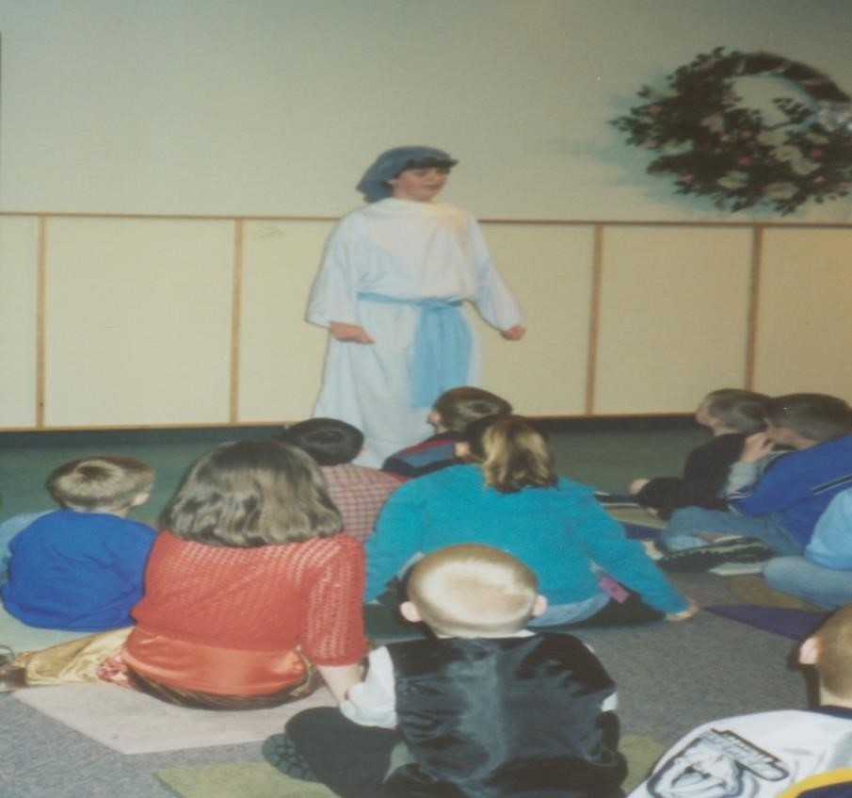

**1 Samuel 1:1-28**

My name is Samuel, and my name means, "heard of God." My mother, Hannah, named me this because she had prayed to God for so long for a son. She talked to Eli, the priest, in the temple, and Eli told her that God would answer her prayer.

My mother, Hannah, was so thankful to God for a son that she told my father, Elkanah, that she planned to give me to

God to serve Him forever. When I was born, my mother kept me until I was old enough to leave her. She then took me to Eli, the priest. My mother took sacrifices to offer to God, and she said, "For this child I prayed: and the Lord has granted me the prayer that I made to Him. Therefore, I have lent him to the Lord; as long as he lives, he is given to the Lord."

My mother prayed again to God to praise Him for His goodness and greatness. My parents went home to Ramah, but I stayed at Shiloh with Eli, the priest. I began to serve God on that day.

My mother made me a little robe each year when she came up with my father to offer the yearly sacrifice. God is so good. He blessed my mother with three more sons and two daughters.

Eli, the priest, is beginning to lose his eyesight. I do whatever I can to help. The other night when I was lying down in the temple of the Lord where the ark of the Lord is, I thought that I heard Eli call my name three different times. Eli told me when I went to see what he wanted for the third time, that it was the Lord who was calling me. Eli said to me, "Go, lie down; and if He calls you, you shall say, 'Speak, Lord, for your servant is listening.’"

When the Lord called, “Samuel! Samuel!” I replied, “Speak, for your servant is listening.” The Lord told me that He was about to punish Eli*s house forever, because Eli knew that his sons were sinning against God, and he did not stop them.

The next morning, Eli asked me what the Lord had said. Although I really did not want to do so, I told Eli all that the Lord had said. Eli accepted what the Lord had said, saying, “It is the Lord; let Him do what seems good to Him.”

As I grew, the Lord continues to be with me. Everyone in Israel from Dan to Beersheba knows that the Lord has chosen me to be a prophet of the Lord. The Lord revealed Himself to me in Shiloh by the word of the Lord.

**Memory Verse**:

☼ Ask, and it will be given to you; seek, and you will find.

**What did you learn from this lesson?**

☺ Like Samuel we should say “speak Lord your servant is listening.

**Do you know? Answer on back page**

**?** **Who called Samuel during the night?**

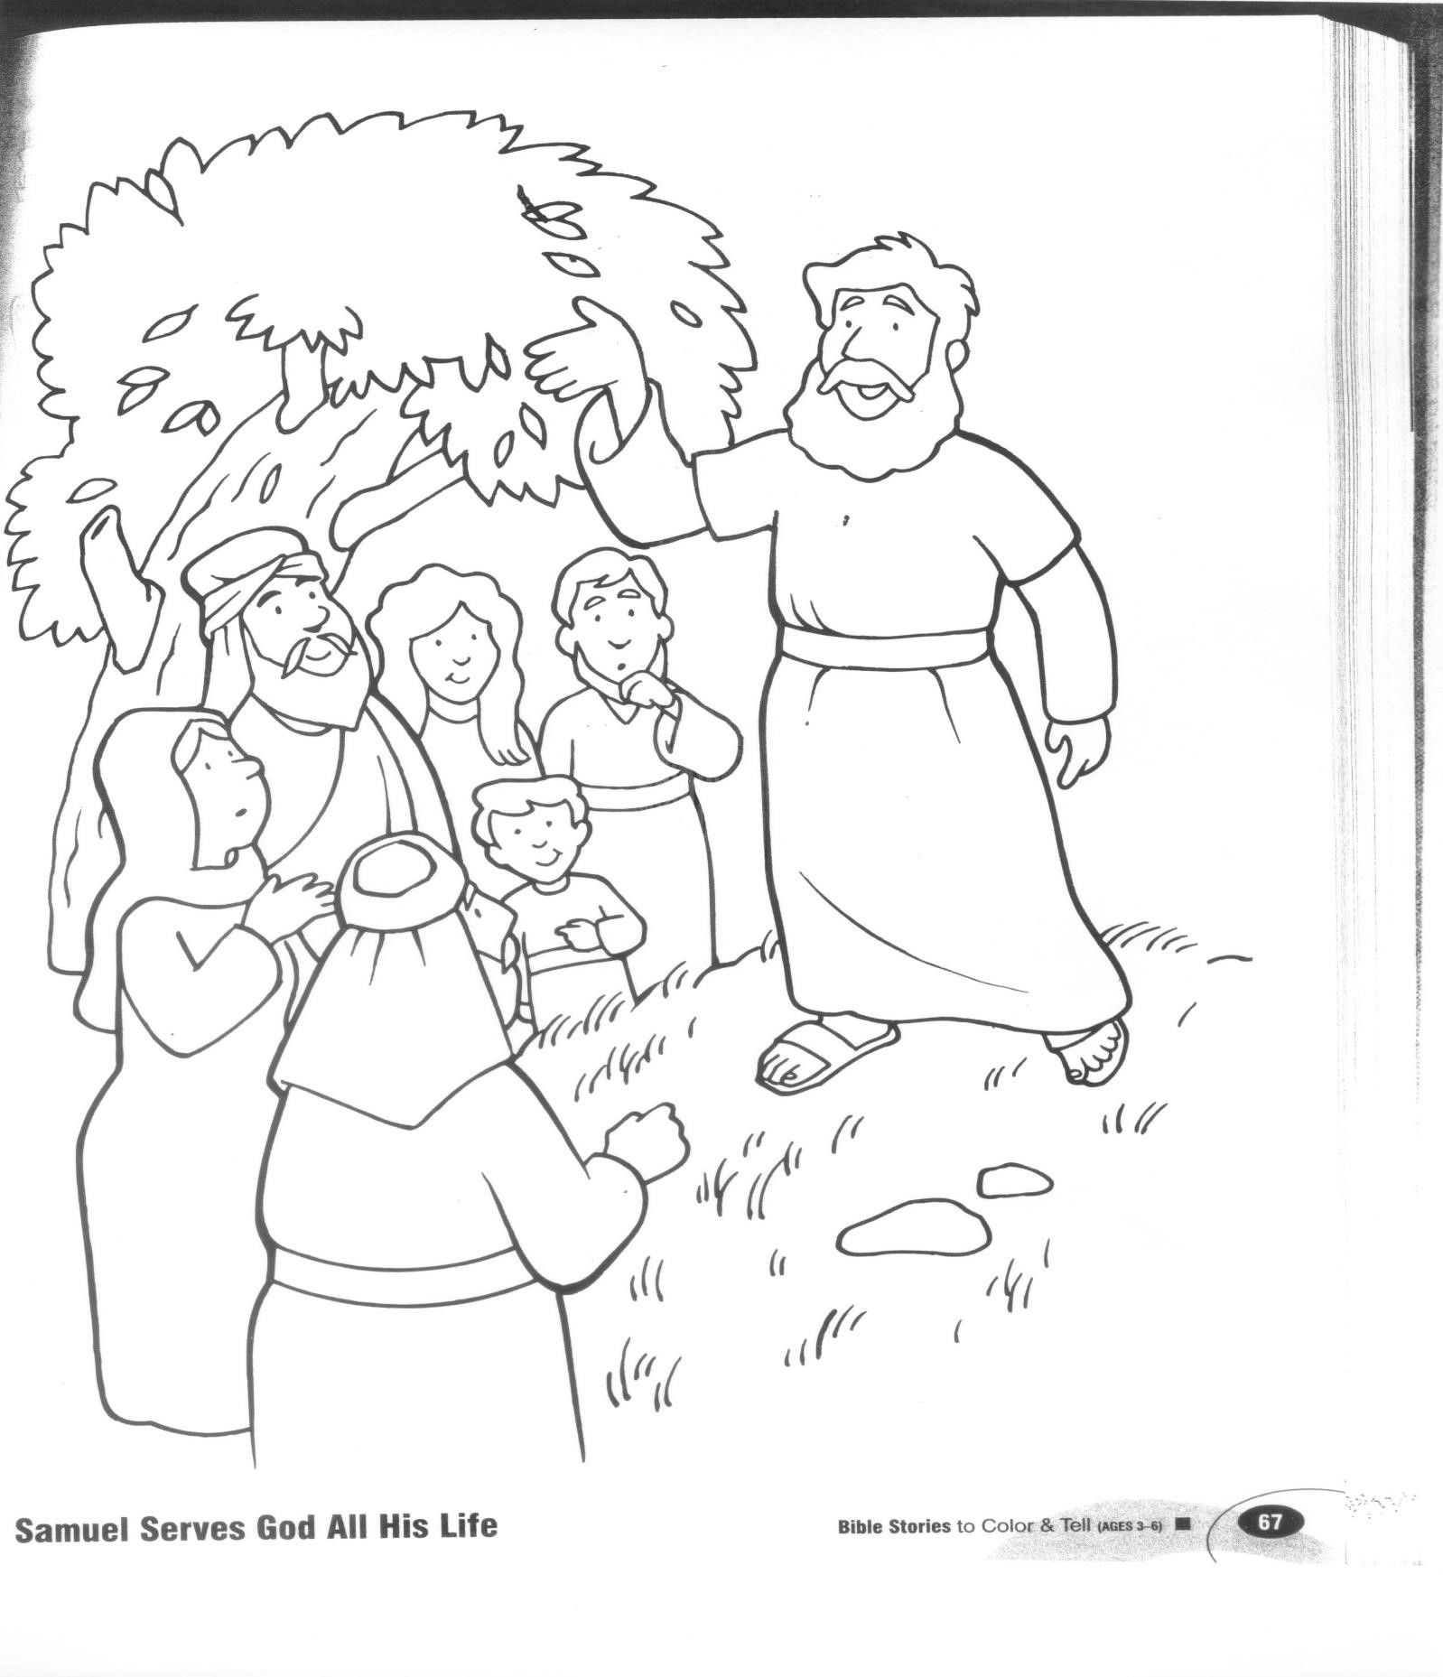

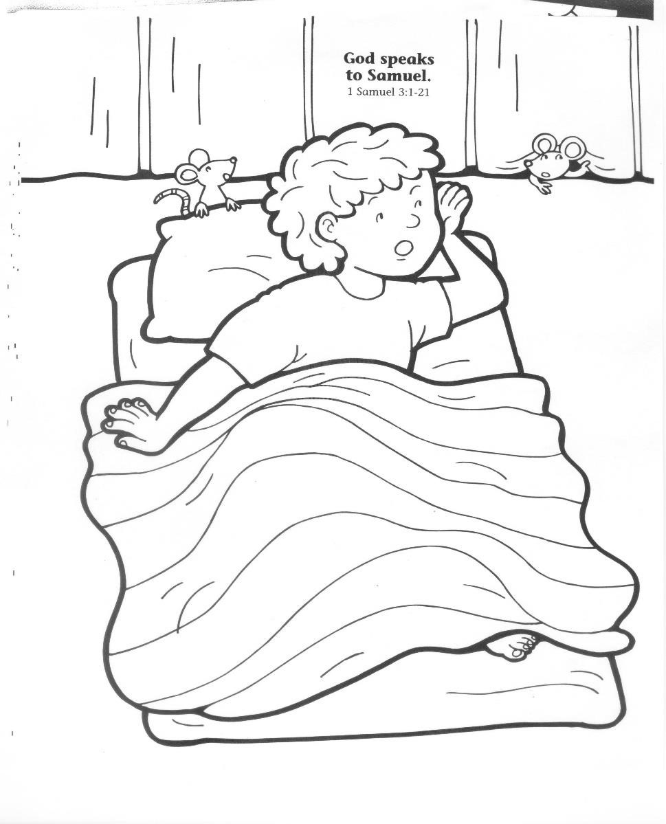

**? Answer to do you know.**

**● God.**